BRIGHTON WIN COWIE SHIELD

Different format, different players, and a win for the Brighton League team in this year’s event held at Portslade Sports Centre on 24 September.
Teams consisting of 3 mixed pairs, made up from players who played 2nd division matches last season, represented Brighton, Crawley, Hastings, West Weald and Worthing leagues. Using rally-point scoring, a number of tight matches were played during the day, with the Brighton team coming out ahead of Hastings and Crawley.

The winning team was Colin Spicer & Carol Hudson (Hassocks), Paul Barnett (Arcadians) & Sue Baker, Daryl Todd (Hassocks) & Sarah Yates (Steyning).

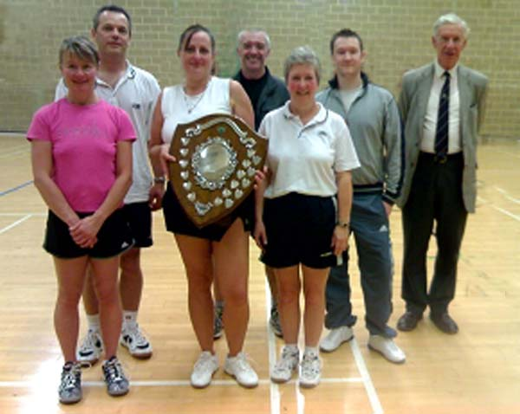

Report: Tony Browne
Photo: Vanessa Bramble

